Project Name |  | Confidentiality Level
YHBDMS |  | For Recipients’ Reference Only
Project ID | Version | Document Code
 |  | Project ID_SD_001

YHBDMS Software System Design Specification



Copyright © Ruankosoft Technologies(Shenzhen), Co., Ltd.
. All Rights Reserved
Revision Record
Date | Revision Version | CR ID /Defect ID | Sec No. | Change Description | Author

Content
1 Introduction 5
1.1 Purpose 5
1.2 Scope 5
1.2.1 Name 5
1.2.2 Functions 5
1.2.3 Applications 5
2 Level 0 Design Description 5
2.1 Software System Context Definition 5
2.2 Design Considerations 5
2.2.1 Design Alternatives 5
2.2.2 Design Constraints 5
2.2.3 Other Design Considerations 6
3 Level 1 Design Description 6
3.1 System Architecture 6
3.1.1 Description of the Architecture 6
3.1.2 Representation of the Business Flow 6
3.2 Decomposition Description 6
3.2.1 Database Management 6
3.2.2 Table Management 6
3.2.3 Field Management 6
3.2.4 Data Management 6
3.3 Dependency Description 6
4 Level 2 Design Description (Optional) 6
4.1 Create Database 7
4.1.1 Design Description 7
4.2 Add Table 7
4.2.1 Design Description 7
4.3 Add Field 7
4.3.1 Design Description 7
4.4 Data Management 7
4.4.1 Design Description 7
5 Data Structure/Database Design 7
6 UI Design 7
Keywords:
Abstract:
List of abbreviations: Describe abbreviations in this document, full spelling of the abbreviation and Chinese explanation should be provided.>
Abbreviations | Full spelling | Chinese explanation
BDMS | Database Management System | 数据库管理系统

- Introduction

Purpose
1. To obtain kmowledge of business background, and learn the function of‘DBMS’.
2.To understand Microsoft Visual Studio 2013
3.To master++ Fundamental Programming. To master MFC framework,including MFC Dialog ,MFC SDI,Tree View and Basic Controls.
4.To master the DDL function, DML function and DCL function of the DBMS,
5.To understand OS conception, thread and process operation.

Scope
    - Name
YHBDMS
    - Functions
Database Management, Table Management, Field Management, Data Management
Index Management, Client Management, Transcation Management, Integrity Management,
    - Applications
Database Maintenance and Security Management
- Level 0 Design Description

Software System Context Definition
This system is used to modify DDL, DML, DQL and so on.

Design Considerations
    - Design Alternatives
First, we use MFC to compile the codes.
Second, we save data like the picture below.
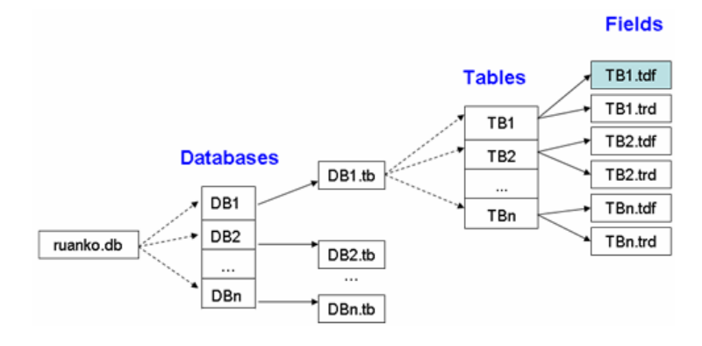
    - Design Constraints
      - Standards compliance
<软酷卓越实验室COE技术要求规范><软酷卓越实验室COE编程规范要求>
      - Hardware Limitations
Low limit: CPU 1GHZ, internal storage 128MB.
      - Technology Limitations
Standard: 软酷卓越实验室COE编码规范
    - Other Design Considerations
Describe other design considerations of the software system.
- Level 1 Design Description

System Architecture
    - Description of the Architecture
The software system architecture should be described here. Architecture diagrams, hierarchical decomposition diagrams, or package diagrams could be used to represent the architecture. And the partitioning principle, such as the architecture defined in a standard protocol, a scheme coming from the analysis model, or the constraints to be followed to integrate with the legacy systems, should also be depicted. The responsibilities and relationships of the analysis classes should be clarified while an analysis model is introduced.
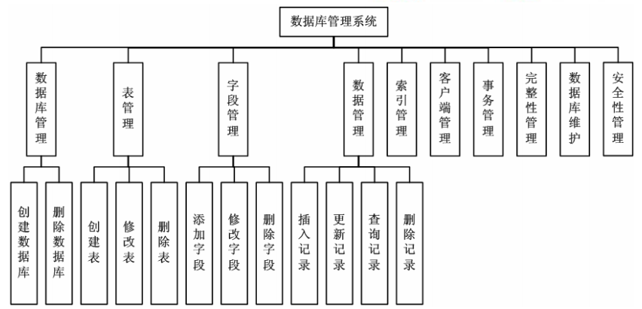
    - Representation of the Business Flow
Sequence diagrams or collaboration diagrams could be used to illustrate the specific use case(s) scenarios from the use-case model to represent the final system architecture or analysis classes，and how these architectural modules work.

Decomposition Description
This section describes the packages, sub-systems, modules in the system.
    - Database Management
- Overview
Create or delete database.

- Functions
SQL language.
Create database: CREATE DATABASE<database name>
Delete database: DROP DATABASE<database name>
    - Table Management
- Overview
Add, modify, and delete table.
- Functions
SQL language.
Create table: CREATE TABLE<table name>
Modify table: ALTER TABLE<table name><alter table action>
Delete table: DROP TABLE<table name>
    - Field Management
- Overview
Add, modify, and delete field.
- Functions
SQL language.
Create field: ALTER TABLE<table name>ADD COLUMN<column name><column definition>
Modify field: ALTER TABLE<table name>MODIFY COLUMN<column name><alter column action>
Delete field: ALTER TABLE<table name>DROP COLUMN<column name><drop behavior>
    - Data Management
1. Overview
Add, modify, check, and delete data.
2. Functions
SQL language.
Insert record: INSERT INTO<table name><column name list>VALUES<insert value list>
Update record: UPDATE<table name>SET<column name>=<update value> [WHERE<search condition>]
Select record: SELECT * FROM<table name>[WHERE<search condition>]
Delete record: DELETE FROM<table name>[WHERE<column name>]

Dependency Description
This section describes the relationships among the design entities such as sub-systems, data stores, modules, processes, etc.
Structure charts, transaction diagrams could be used to represent dependences.
- Level 2 Design Description (Optional)
Each module that is defined in L1 and identified for further description shall be stated by separate sub-sections as mentioned below. More sub-section levels could be added optionally, and finally all specific classes corresponding to each final minimal module, including its public attributes and pubic methods, should be defined.
This will be repeated for each package/module as follows.

Create Database
    - Design Description
      - DBLogic
To check the database exists or not. If it doesn’t exist, create it.
      - DBView
To show the database.
      - DBMSDoc
To control the interface.

Create Table
    - Design Description
      - AddTable
To create a new table in the database.
4.3 Create Field
4.3.1 Design Description
4.3.1.1 AddField
To add a new field in the table.
4.4 Data management
4.4.1 Design Description
4.4.1.1 CheckRecord
To check the data flow record.

- Data Structure/Database Design
BOOL, CString.
- UI Design
6.1 Main View
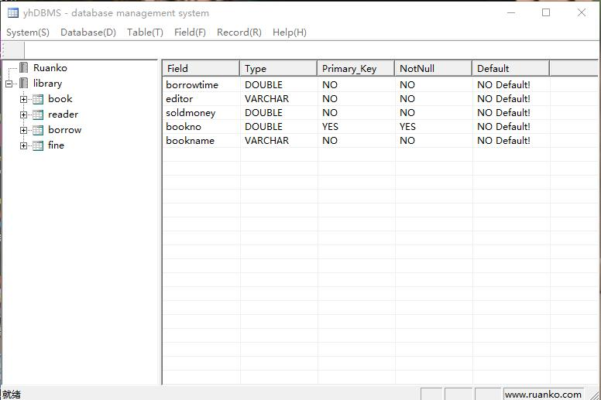
6.2 Add Field
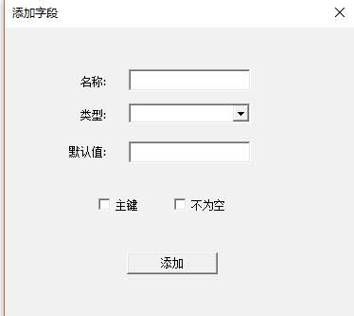
6.3 Insert Record
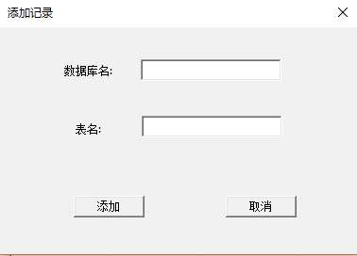
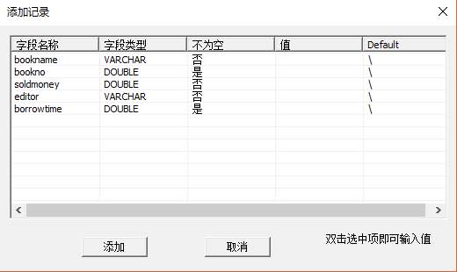
6.4 Modify Record
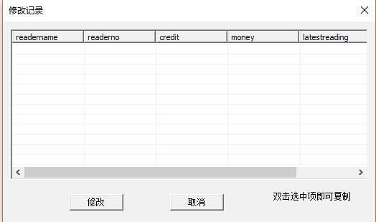
6.5 About
